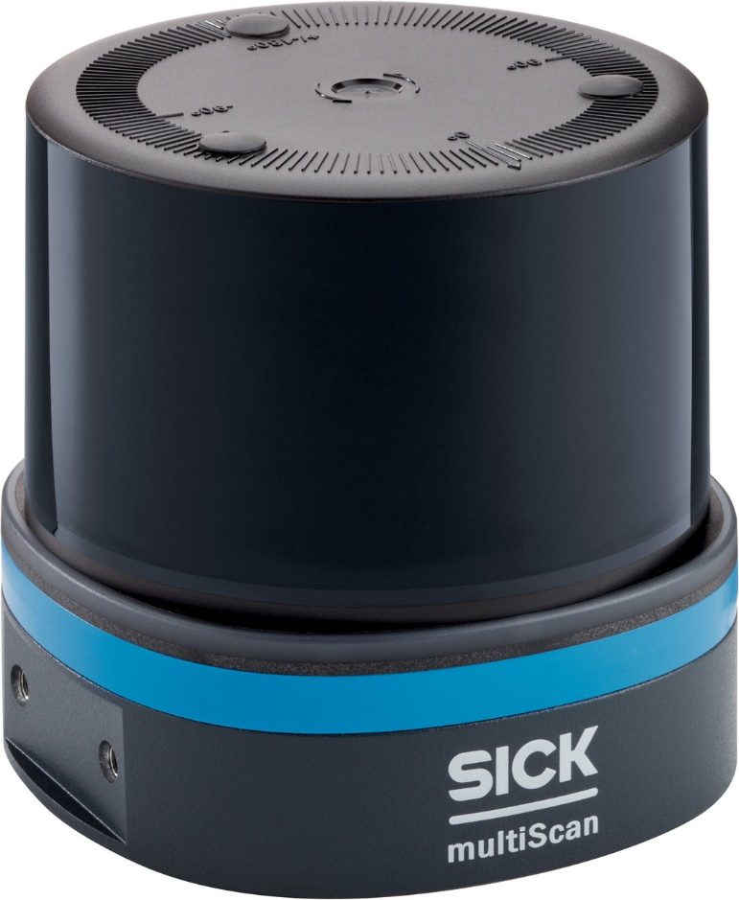

The August 2023 List Price for the multiScan is $4,827.00

