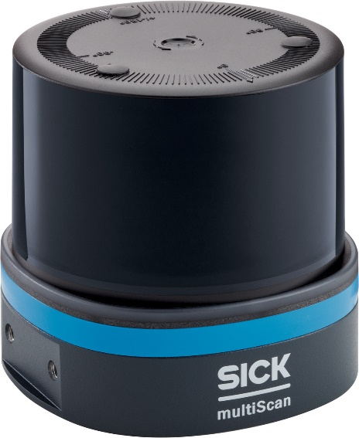

SICK$10K Challenge
September 15th 2023 – March 15th 2024

Summary of the contest:
SICK is a leading global manufacturer of factory, logistics and process
automation technology worldwide. With more than 1,000 patents for its products, SICK continues to lead the industry in new product innovations.
SICK Inc., is excited to announce a challenge for universities across the
nation to support innovation and student achievement in automation and
technology. Fifteen teams will be selected to participate in the challenge
and the chosen teams will be supplied with a SICK 360° lidar (multiScan) and accessories. The teams will be challenged to solve a problem, create a solution, and bring a new application that utilizes the SICK scanner in any industry. This can be part of the curriculum for a senior design project or capstone project for students.
The multiScan100 3D LiDAR sensor is a real multi-talent. Thanks to its high-resolution 0° scan layer, it is suitable for mapping and localization. The sensor generates a 3D point cloud that can be used to detect people and objects. It effortlessly detects fall edges and overhanging obstacles. This is how it reliably protects mobile platforms from accidents and failures. Thanks to its large working range, the sensor is also suitable for stationary applications. The multiScan100 can be individually configured and easily integrated. In addition to the device, there is a continuously growing modular software system with apps and software add-ons. A system plug for common interfaces ensures quick and flexible implementation. More information on the multiScan is on our website:

multiScan100
Of course, student teams are encouraged to use their creativity and technical knowledge to incorporate the SICK lidar in any application for any industry. Advisors/Professors are allowed to guide student teams as and when required.
Timeline
- Register your team at https://s.sick.com/us-en-10kchallenge prior to Sept 15, 2023, including an abstract of your project proposal.

1

- All registered teams will receive a multiScan100, cables and mounting bracket from SICK. The 15 selected teams will receive the multiScan and accessories as a product donation by Sept 30, 2023. The selection of these 15 teams for the 2023-2024 challenge will be based on the winning criteria.
- Check in #1 with the SICK $10K program team during the week of December 4th, 2023 (Project Update #1)
- Check in #2 with the SICK $10K program team during the week of February 12th, 2024 (Project Update #2)
- Final paper and video submission by March 15, 2024 in your folder on box.com
- Winners Announced the week of April 1, 2024
- Summer 2024 – Winning team and Advisor travel to Minneapolis, MN for Winners’ Award Trip

Awards
A panel of judges will adjudicate the final submission outlining the working prototype of the invention in March - April 2024. The criteria used to award the winners are:
• Creativity and Innovation
• Ability to solve a customer problem
• Commercial potential to productize and market the application
• Entrepreneurship of the team
• Reporting
The 3 winning teams will win a cash award of
1st Place - $10K
2nd Place - $5K
3rd place - $3K
In addition to bragging rights and the cash prize, the 1st place winning team, along with the advising instructor, will be offered an all-expenses paid trip to Minneapolis, MN to visit the newly opened US SICK headquarters and manufacturing facility in summer 2024.

Rules of the contest
1. The competition is organized by SICK Inc., 6900 West 110th St, Minneapolis, MN 55348 and
supported by PMMI. Contest managed by Bryan Sellars (bryan.sellars@sick.com)
2. The contest will span most of the 2023 - 2024 school year.
3. The contest is aimed at technical students, and it is a team contest. Fifteen teams will be admitted to the contest. The teams may consist of 4 students. Up to 6 students per team may participate if the contest manager is notified.

2

4. Excluded from the challenge are any SICK employees or their relatives, members of the panel of
judges, representatives of potential partners or other individuals that are part of the organizing team.
5. By registering for the challenge, the participants agree and commit to the competition rules.
6. Participating teams agree to grant permission to SICK for all media (such as drawings, illustrations, pictures, videos and screen shots) to use and publish in both print and digital format, with or without names of the participating students and institutions for any lawful purpose, including purposes such as publicity, illustration, advertising, press releases and web content.
7. It is mandatory for the entries to be a new application of the SICK multiScan100. The challenge will accept only ideas that are unique, not yet known, commoditized, or placed on the market. The existing laser scanner solutions can be found on the SICK website. We recommend that you highlight the objective, benefits, design, uniqueness, and operation of your application. Pictures, videos, drawings, or any other illustrations are more than welcome!
8. The best teams will be awarded by the panel of judges and results are final and binding. Teams that
do not meet the deadline will be considered disqualified. The panel of judges reserve the right to ask for additional information or submit questions to participating teams.
9. The participating teams are responsible for originality, concept, and design of the idea. In addition, it must not be the property of a third party. By registering for the challenge, the participants state in to SICK their entry will not violate any confidentiality clauses or third-party intellectual property rights or other associated rights.
10. SICK will assume intellectual property rights if participating teams fail to identify any IP restrictions in their final submission.
11. The participating teams will agree to be subject to the laws of the city, county, and state that they are located and are legal in the United States.
12. Regarding autonomous (driverless) vehicles: All submissions that use lidar for the control of a moving vehicle must be tested and demonstrated only in controlled off-road environments and not on public roads. Submissions that fail to meet this requirement will be removed from the competition.
Contact information
Technical Questions: techhelp@sick.com
Program Manager: Bryan Sellars, bryan.sellars@sick.com
Links:

SICK, Inc: www.sick.com
Product information of the multiScan LiDAR:
https://cdn.sick.com/media/familyoverview/4/14/914/familyOverview_multiScan100_g574914_en.pdf?_gl=1*1ayz87d*_gcl_au*MTk4NDI0OTI2NC4xNjg1NDcyNTQw
Technical information:
https://cdn.sick.com/media/docs/1/11/211/operating_instructions_multiscan136_3d_lidar_sensor_en_im0104211.pdf?_gl=1*1rfqvqm*_gcl_au*MTk4NDI0OTI2NC4xNjg1NDcyNTQw

3

